Task 1:
- Entity team:
- Each team may or may not have an assigned coach
- Each team has minimum amount of player is 1, and maximum is 12 players.
- Each team can have maximum amount of coaches is 3
- Entity player:
- Each player is registered by at least 1 parent
- Each player belongs to only one team
- Entity parent:
- Each parent can register at least 1 player
- Entity coach:
- Each coach may have one of following specialty: OFFENSIVE, DEFFENSIVE, or PHYSICAL.
- Each coach can be assigned to only one team.
Task 2:
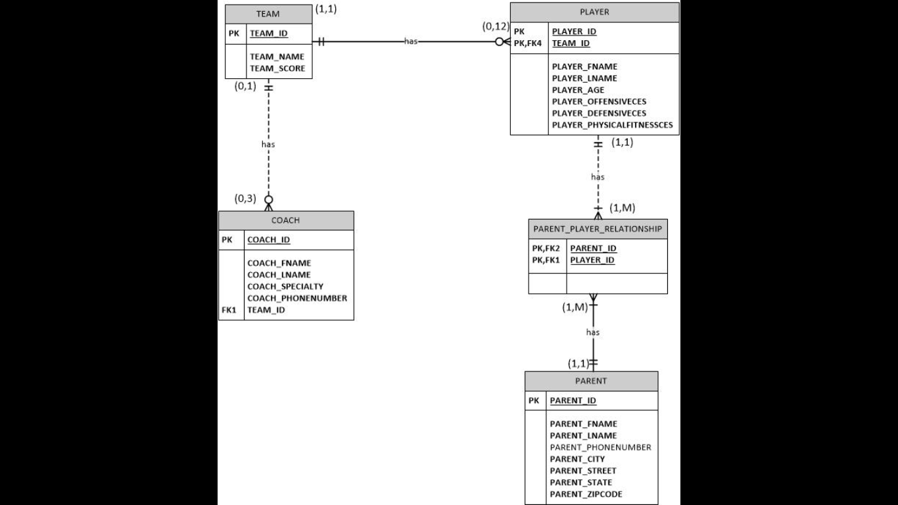

Task 3:
MS Excel
Task 4:
MS Access
Task 5:
Assumptions:
First, a parent could not have so many children, so that I think the maximum amount of player that a parent can register is just two. A team should have at least one coach, if they do not have a coach then it is really difficult to play as a team without planning or strategy.
Limitations:
All the ID number, age, or score I will use as number. Some of it, such as age or ID, I use char(xx). For example, the ID number will be char (10) because it is the same as student ID, all the ID number will just have ten numbers, so it is fixed. The size of street is 200 because maybe the parent lives in a very small place, so there will be a lot of street, big and small streets. The phone number cannot be specified range because parent can have a lot of phone numbers, and they can come from other countries, there do not have a fixed range to specify it.

